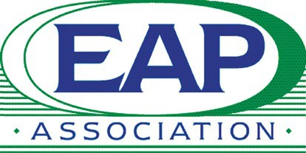
Employee Assistance Professionals Association UK Ltd

Annual General Meeting - Agenda

Tuesday 10 March 2026, 5.30pm

Surrey Room, Hilton Metropole Hotel, NEC Birmingham, B40 1PP & Online via Teams

The 27th Annual General Meeting of Employee Assistance Professionals Association UK Ltd will be held on Tuesday 10 March 2026 at 5.30pm.
Our AGM is open to all EAPA UK members (organisations and individuals) and all other individuals and conference delegates interested in mental health, wellbeing and OH.

Agenda

5.30pm EAPA UK AGM
- Open the meeting
- Welcome and Apologies
- Approve minutes of the last AGM held on 20 June 2025
- Chair’s address and Projects update
- Treasurer’s report
- PR and Social Media Activity
- Election of Officers and Board Members
- Awards Presentation
- AOB
- Close AGM
- Guest Speaker Sessions

Guest Speaker: Amalie Angelskår, Chief Commercial Officer, Meela
'Client and Counsellor matching’

Guest Speaker: Sam Stern, Co-Founder, Affiniti AI
‘How EAP's can work alongside clinical AI tools'

After the meeting, we welcome you to join the EAPA UK Board for informal drinks at the Hilton hotel bar

