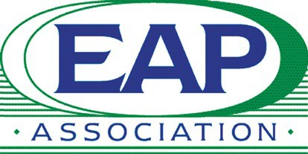
Employee Assistance Professionals Association UK Ltd

Annual General Meeting - Notice

Tuesday 10 March 2026, 5.30pm

I am writing on behalf of the EAPA UK Board to advise you that the Annual General Meeting of the UK Branch of EAPA will be held on Tuesday 10 March 2026 at 5.30pm. The meeting will be held in the Surrey Room at the Hilton Metropole Hotel, NEC Birmingham, B40 1PP & online via Microsoft Teams.

Election of Officers and Board Members

Nominations are invited for Officer and Board roles. This is an opportunity to serve the EAP community in the UK. All roles are voluntary in nature. It is a serious undertaking, and you will be expected to attend Board meetings, as well as undertake project work for the Association.

The following roles are available for a 2-year term:
- Officer: Secretary
- Board role: two positions

Members may nominate themselves for an Officer or Board position by submitting the attached nomination form by email to the Administrator (info@eapa.org.uk). Nominations must be received by 5.30pm on 24 February 2026.

More information on the role and responsibilities can be read in the EAPA UK By-laws (copy attached – see Article IV).

Other essential information:

- Only one person employed by or representing any organisation can become an Officer or Board Member.
- No member can serve simultaneously as both Chair and Treasurer.

If you would like to assist the Association in a project or other work without being on the Board, we would welcome your assistance.

Lifetime Membership Award

As in previous years, members have an opportunity to nominate someone, who they feel has made a considerable contribution to the profession, for a special award. Nominations will be considered by the Board. Please use this opportunity to make a nomination using the attached form.

We look forward to receiving nominations and seeing you at the AGM.
With kind regards,

Karl Bennett
Chair
Employee Assistance Professionals Association UK Ltd
Email: Info@eapa.org.uk

